To Configure Staging Policy Environment

Prerequisite-

1. Staging DB at DB server (i.e.
2. Cloud DB server for Cloud App server)
3. ACON (Policy LOB) dsn
4. DB Server IP must be added to Cloud Application Server Host file.

Navigate to Utilities => Managers => Policy Set Up => Policy System Setup

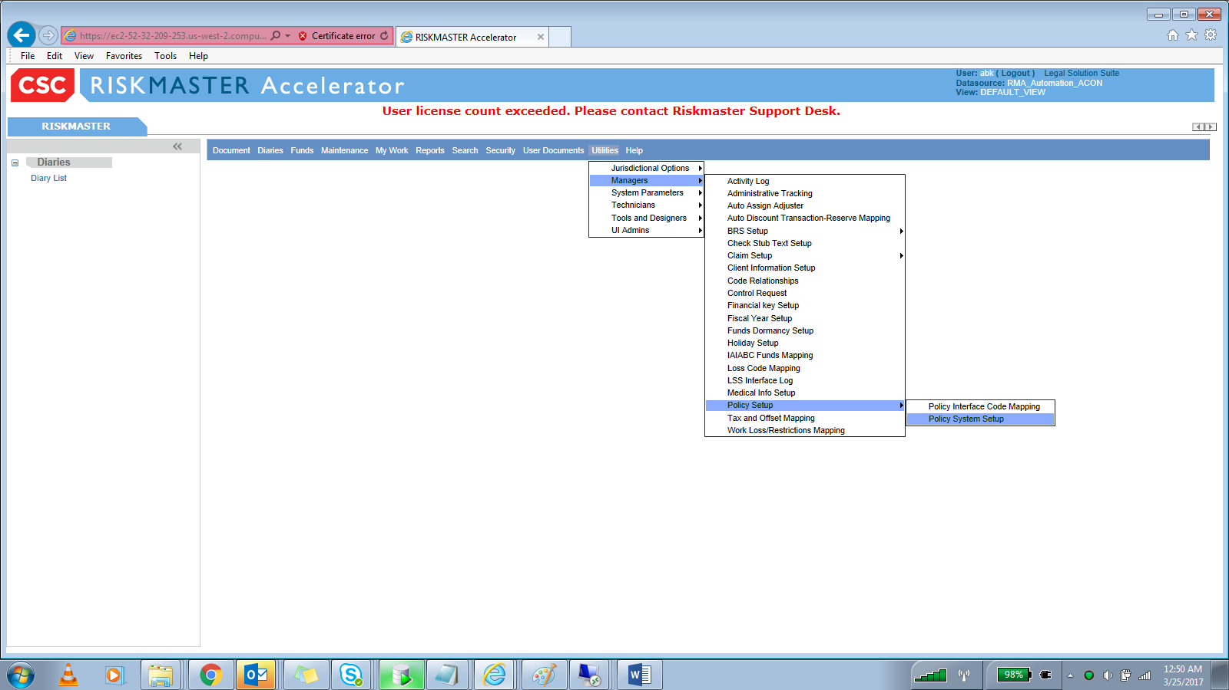

‘Policy System Web Settings’ Page will load.

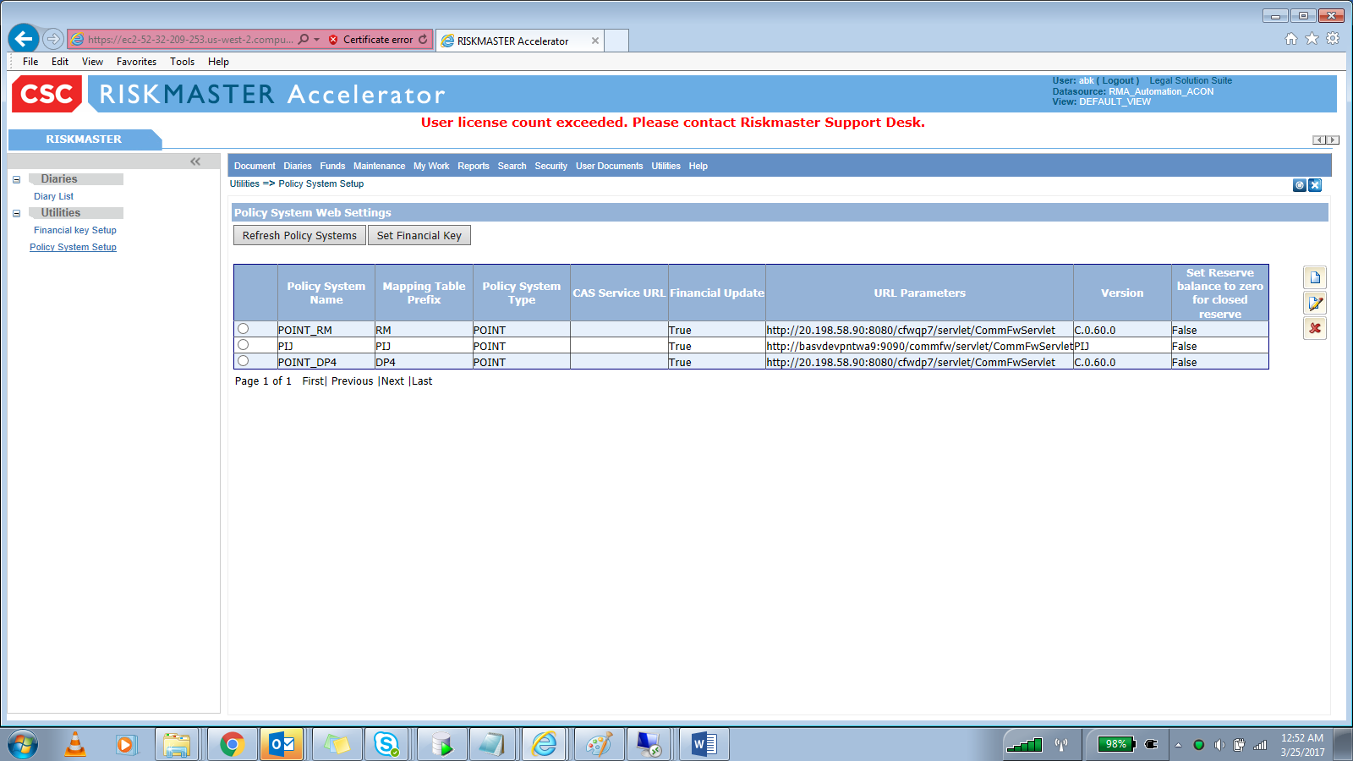

Click New. Policy System Web settings- new window will load

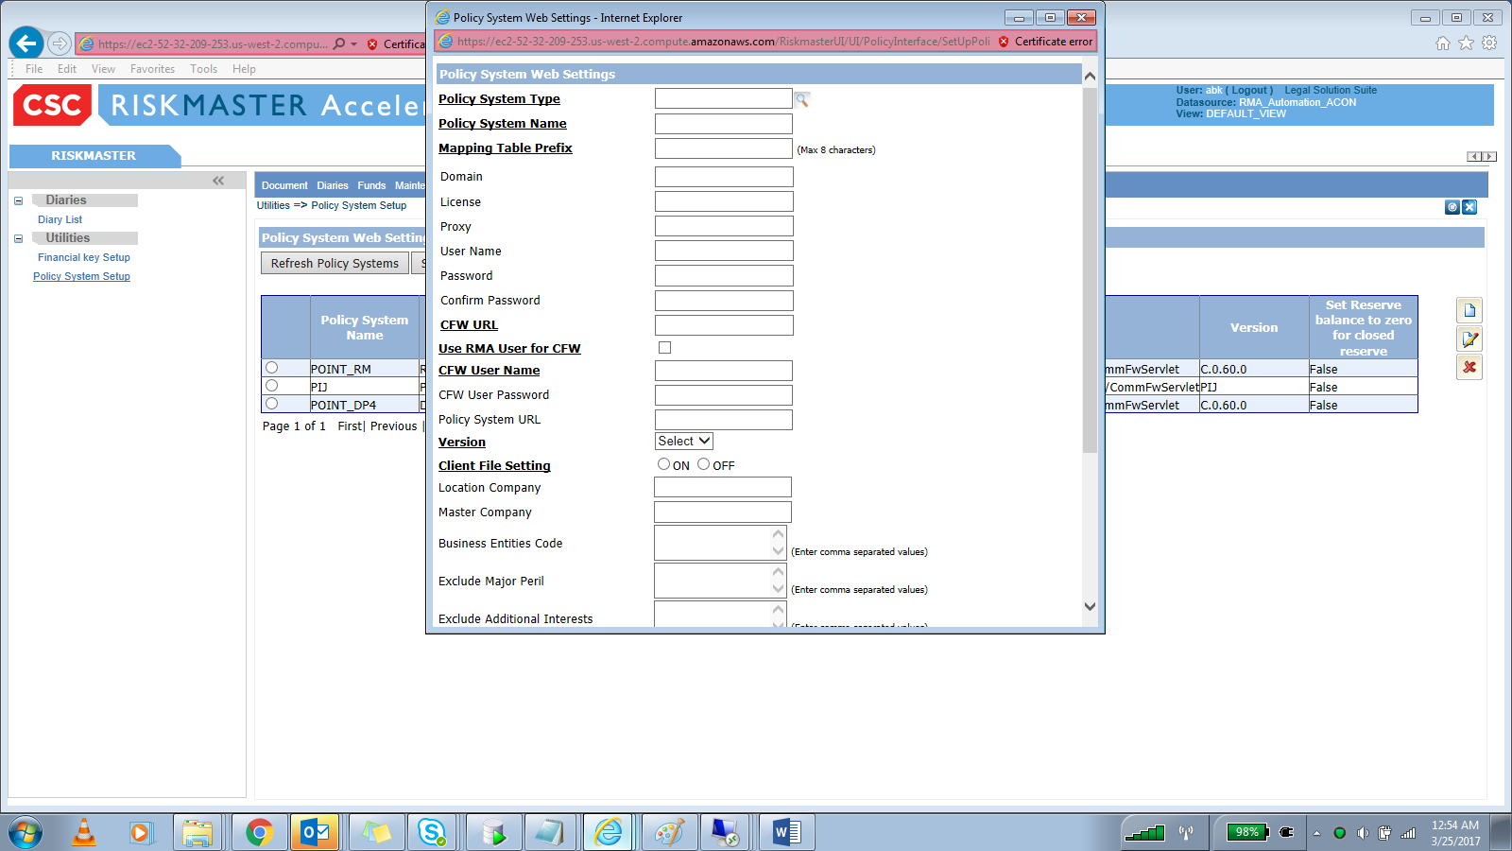

Enter Below details-

Policy System Type : STAGING

Policy System Name: RMAAUTO_STAGING or any desired name

Mapping Table Prefix: CSA02 (Once check with Base QA if this can be user defined)

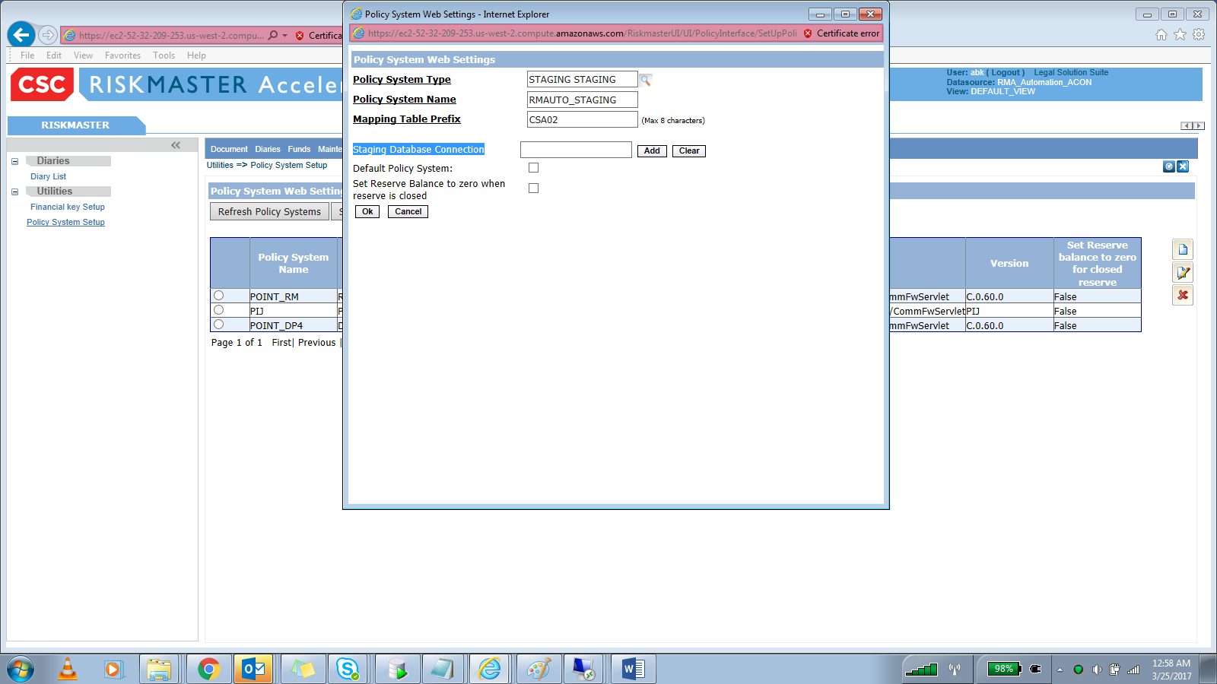

Click Add for setting up ‘Staging Database Connection’ Connection string.

Add New Data Source screen will load.

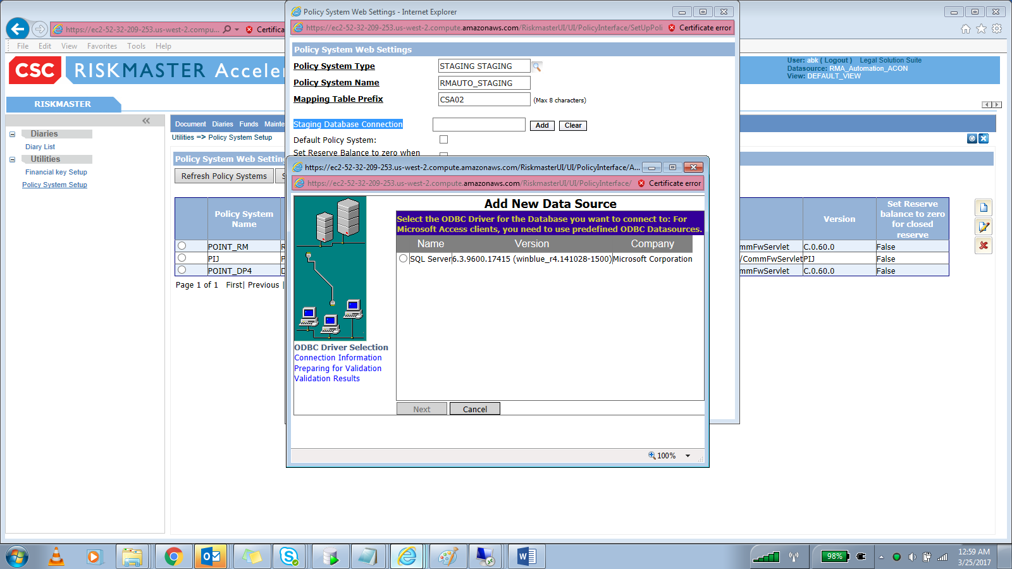

Select SQL server. Click Next

Enter Server name, Database name, SQL server user name & pass.

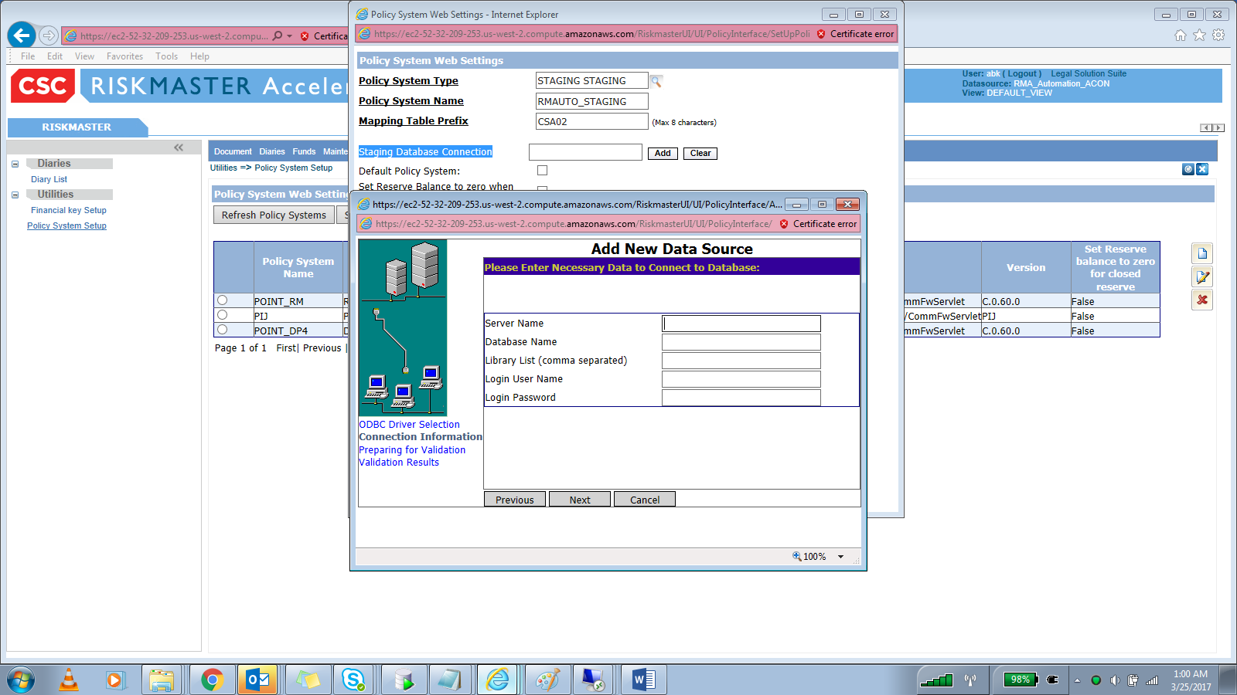

Click Next & Finish.

Encrypted Connection string will be created and updated under field ‘Staging Database Connection’.

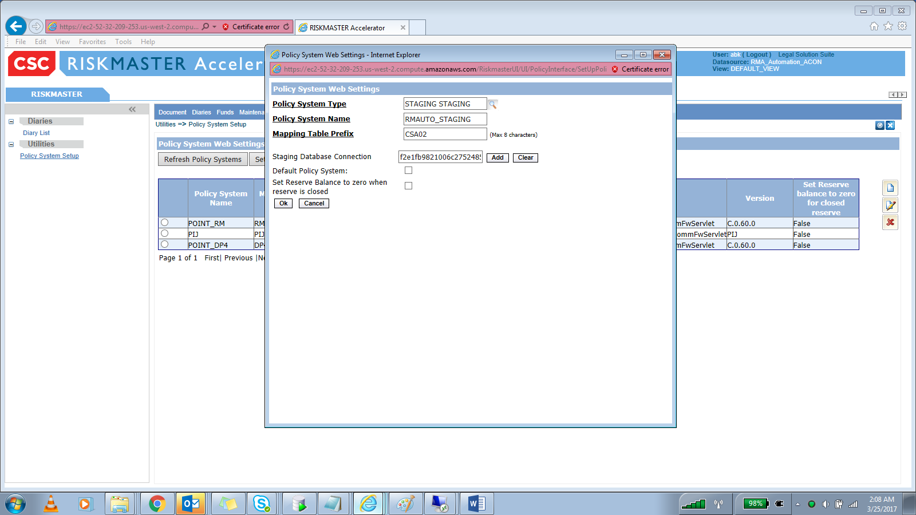

Click OK. Newly created Staging Policy system will be displayed.

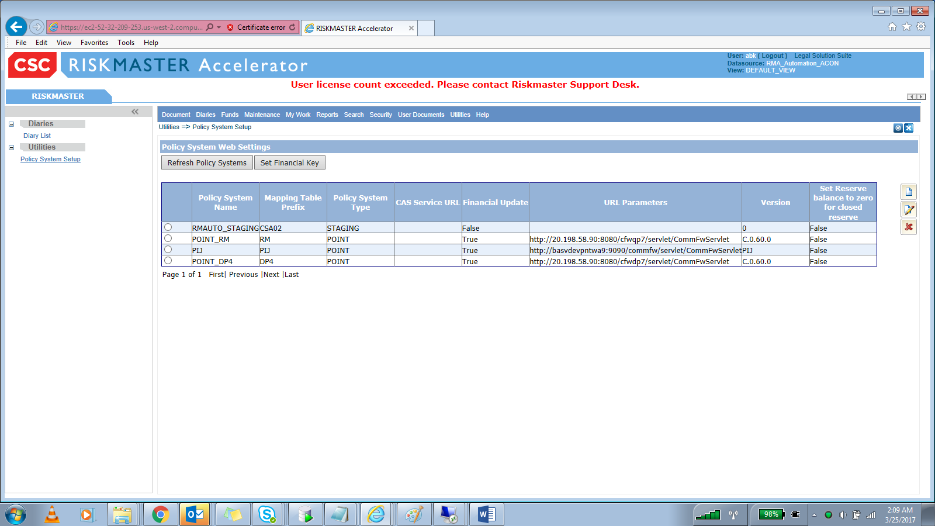

Navigate to Maintenance => Table Maintenance

Verify that System tables got created with given prefix. These Staging tables need to be mapped with RMA codes.

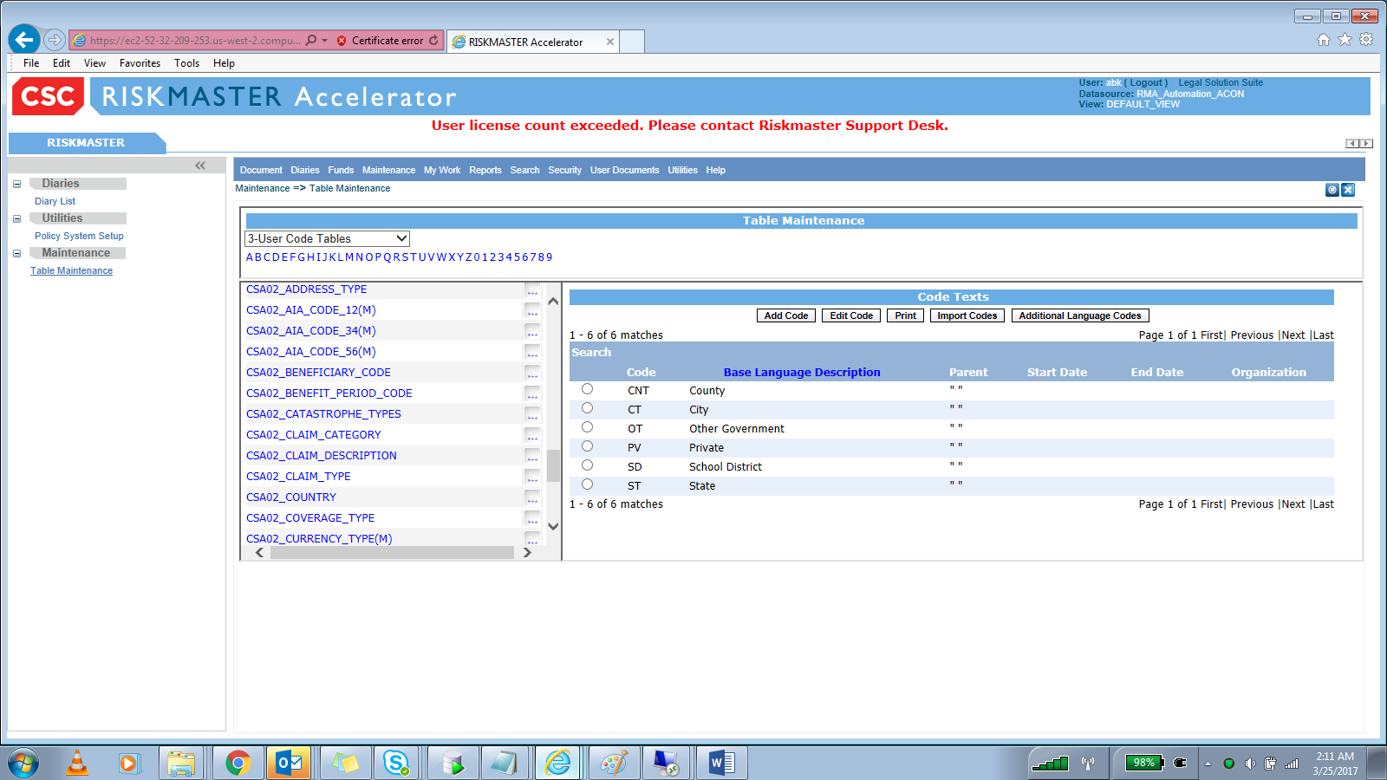

Once tables are mapped. Navigate to Maintenance => Policy System Download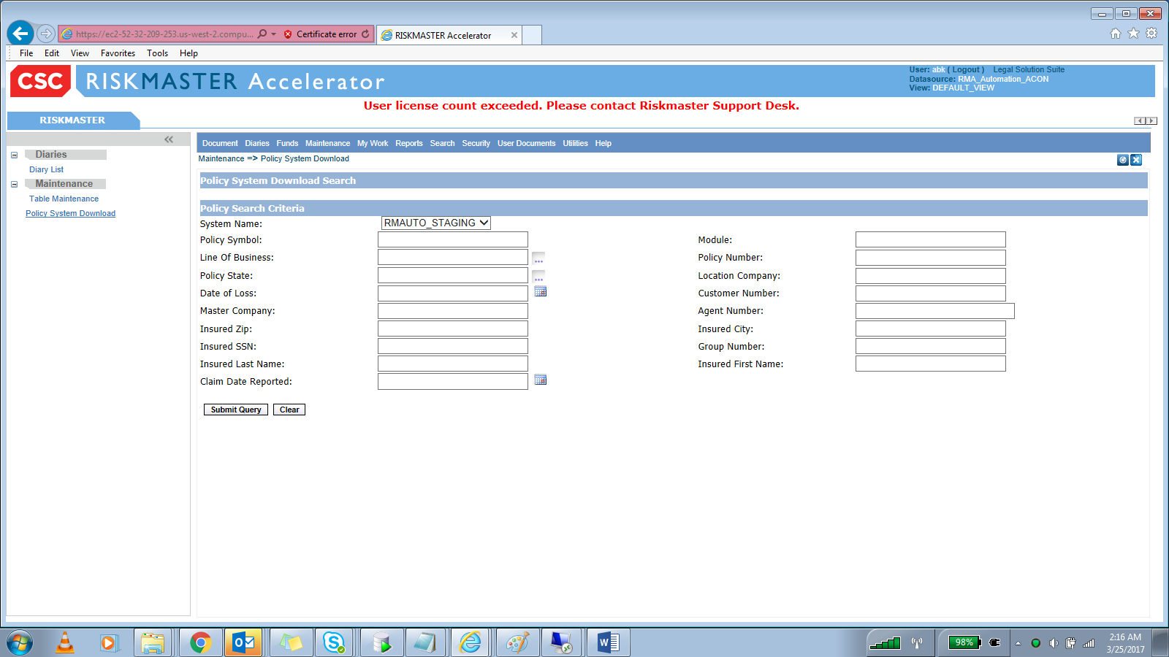

Policy App window will be launched

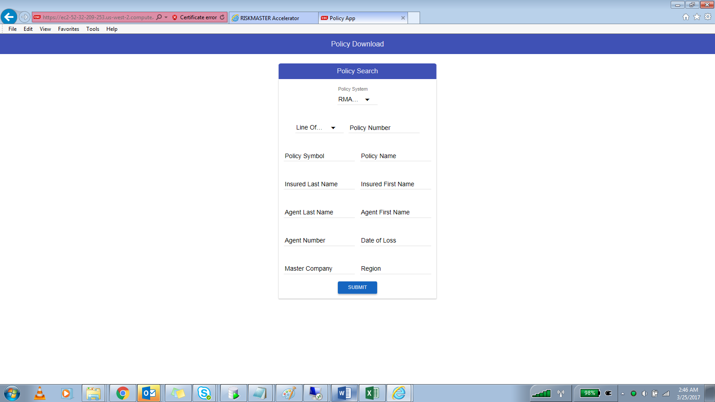

Select Line of Business. Click Submit

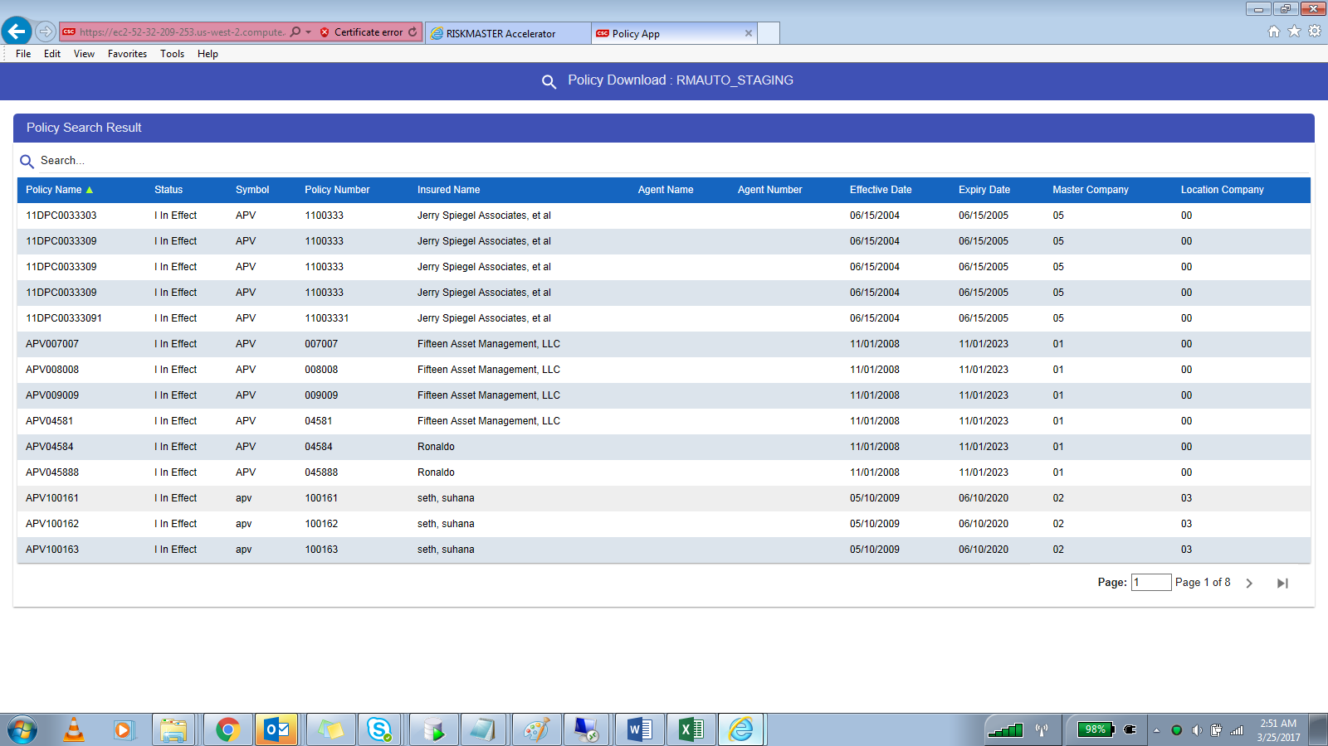

**Troubleshooting:**

1. **If ‘Remote Server not reachable’ message displayed on Policy App window launch after selecting ‘Staging’ policy system under Maintenance => Policy System Download**

Do verify that JSON file is updated with Cloud App server IP in case of configuration on Cloud server in Config.JSON files at below paths

C:\Program Files (x86)\CSC\RiskmasterUX\rmaCommon

C:\Program Files (x86)\CSC\RiskmasterUX\policyApp

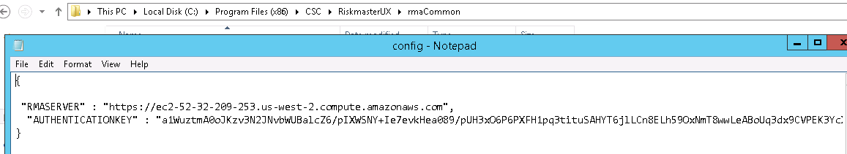

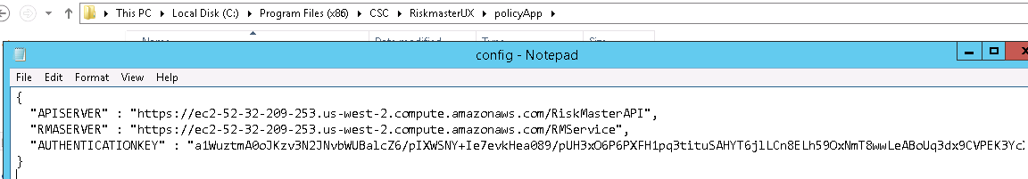

1. **If ‘Forbidden error’ message displayed on UX screen- Do verify below config settings**

**C:\Program Files (x86)\CSC\WCFService\appSettings**

**BaseServiceUrl is updated with correct url**

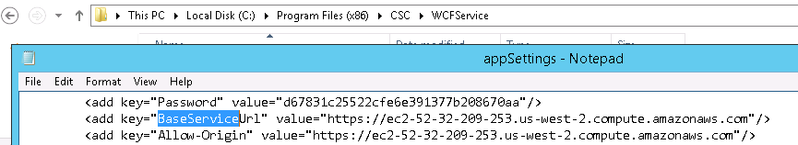

**Copy/paste corrected appSettings file at**

**C:\Program Files (x86)\CSC\RiskmasterAPI\bin**

**b) Ensure that connection string is updated with corrected db server details and**

**same is updated at below below locations-**

**C:\Program Files (x86)\CSC\RiskmasterAPI\bin**

**C:\Program Files (x86)\CSC\WCFService**

**C:\Program Files (x86)\CSC\WCFService\bin**